Mensuration Challenges
- Facts:
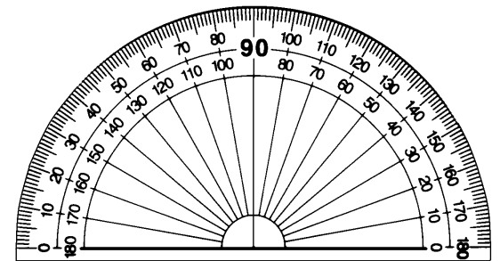
- 10mm = ___cm
- _____cm = 1m
- _____m = 1km
- One full turn = _______degrees
- A right angle = _______degrees
- One hour = ___ minutes = _____ seconds

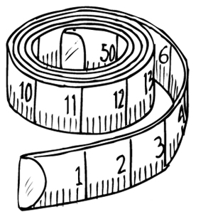
- Find something in the classroom equal to:
- 10cm
- 2m
- 30 degrees
- 90 degrees
- 260mm
- 0.05km

- Measure:
- Your foot in cm
- The bend in your elbow to your wrist in mm
- The biggest angle you can make between your thumb and first finger in degrees
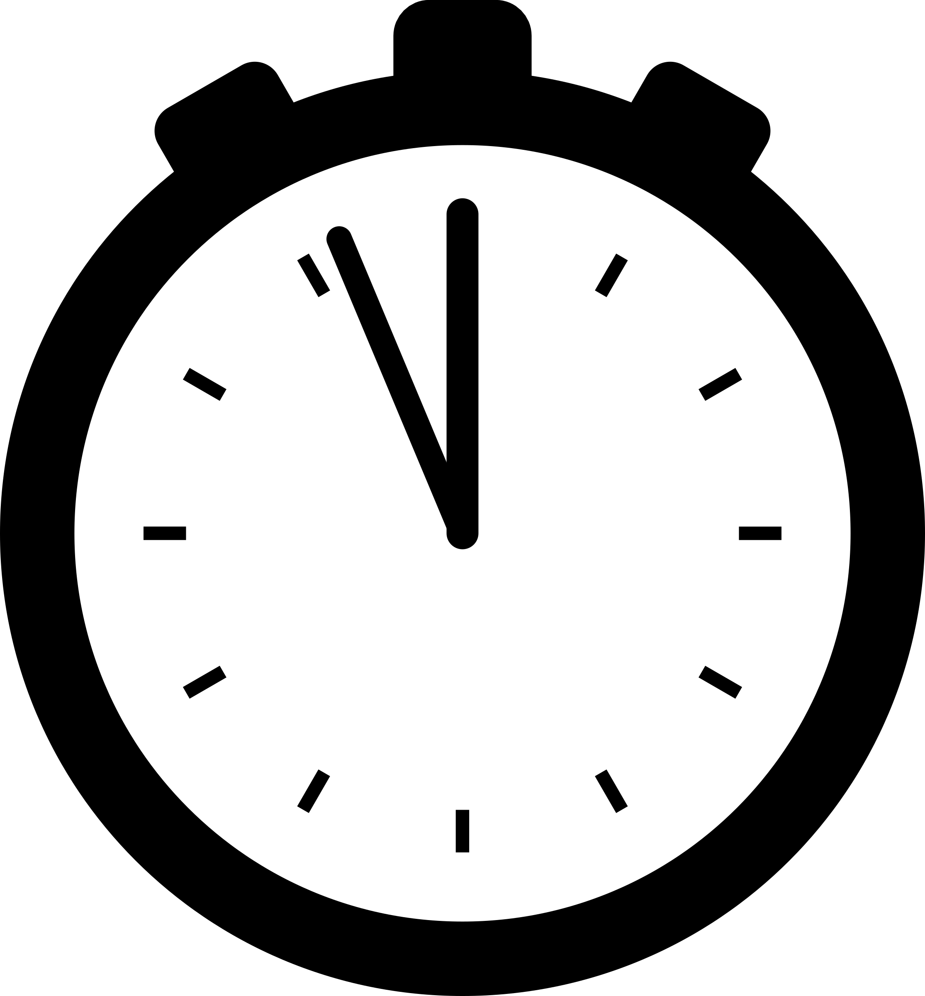
- Your bag in metres
- The width of your chair in cm
- The width of your smile in mm (be very careful)
- How long you can stand on one leg in seconds

- Challenge
Find a group of five different items which are all the same size. You may not just pick the same item in different colours. List and measure them.

