This is it!

You've made it to the
end of the GCSE Maths course.

You deserve an amazing summer
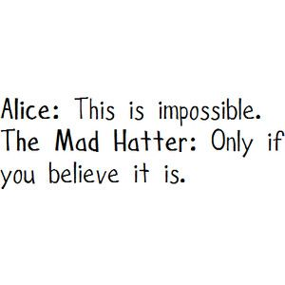
break and a brilliant results day.
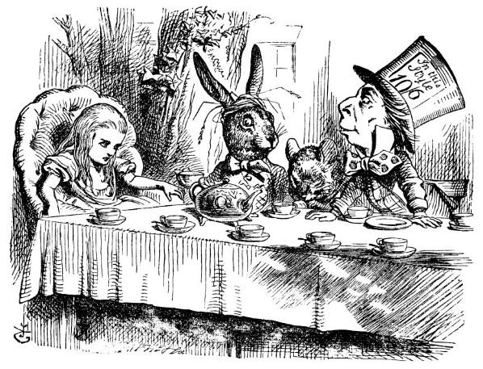
Question: Why is there a picture from ‘Alice in Wonderland’ by Lewis Carroll on the front?

Now if you are thinking of studying A-Level Maths, you should be commended for your astute decision making. However A-level Maths and A-level Further Maths don't have the reputation for being some of the hardest A-Levels for nothing.

What can you do to ensure the best possible start to the course? Well, it's pretty easy really - don't forget everything you studied for GCSE Maths, especially the Algebra. Definitely read through your Algebra notes before September - there is a nice overlap between Grade 7-9 Algebra and the Year 12 course, so if you can keep those skills sharp you should have a good start. If the algebra part of the GCSE wasn't your thing, then you may be at a disadvantage in Y12.

Let's be realistic - no one in their right mind is going to finish all their GCSEs then pick up books for more study. You need to unwind and relax.

Here are some suggestions for ways to keep your maths skills sharp, without the maths text books.

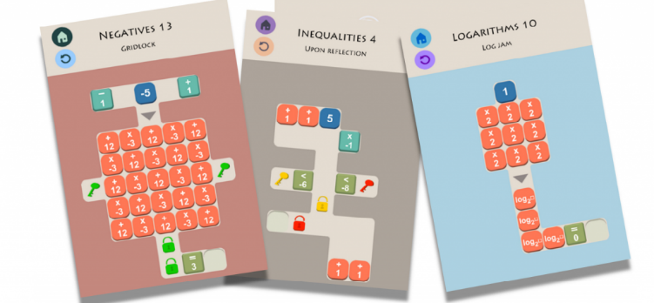
Try the free Sumaze apps
Number and logic problems in a maze-style game. If you have a lot of free time Sumaze 1 can be done in under two days

Investigate YouTube
Look for the Numberphile channel or videos by the 'Festival of the Spoken’ nerd team
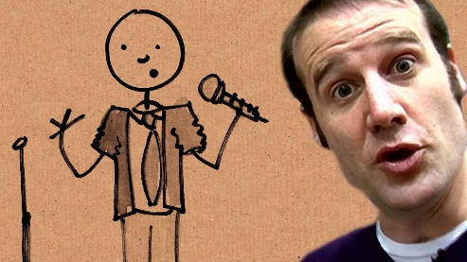
Unsurprisingly Matt Parker (Stand Up Maths) is involved in both

Read a review and watch a film
'Hidden Figures’ PG
'Beautiful Mind’ 12
'The Imitation Game’ 12
You'll be surprised how many results you get if you Google 'maths films on Netflix’, however they aren't all available on the UK service
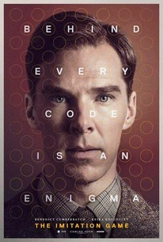
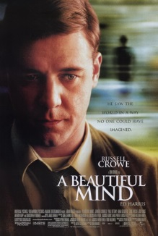

Read a book and follow the authors on social media
‘Alex’s Adventures in Numberland’
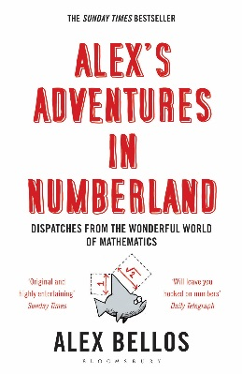
'Bad Science’ by Ben Goldacre
'Professor Stewart's hoard of mathematical treasures’ by Ian Stewart (one of many titles)
‘The indisputable existence of Santa Claus: The mathematics of Christmas’ by Dr Hannah Fry & Dr Thomas Oleron Evans
Anything by Rob Eastaway or Danica McKellar
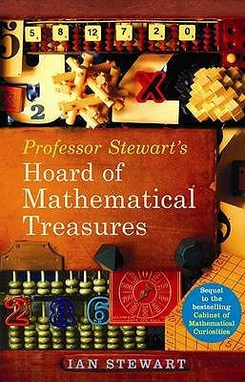
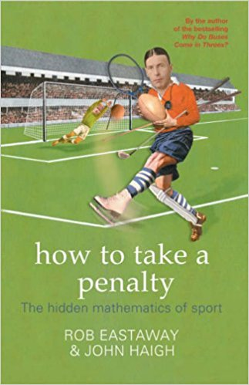
Go to an event
If you get the opportunity to, go to a popular Maths or Science lecture. You'll be surprised where they pop up - even the famous Hay Literary festival has a maths lecture! Don't worry if you don't understand all of it, you won't be alone, but you'll start to see the links between different areas

Puzzles
Invest in some Maths related puzzle books:
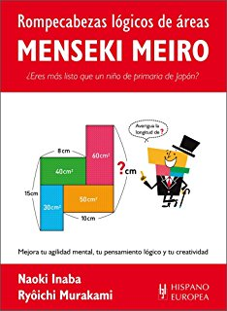
Sudoku, mathdoku, menseki meiro (books are in other languages, but you don’t need the instructions, just the pictures), logic problems
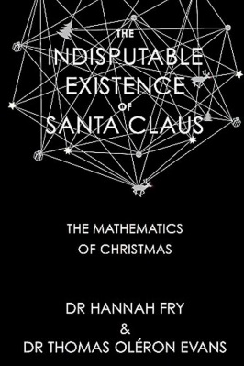
They'll all keep your brain alert

Eat some tubes of Pringles with friends
- Then Google​ Pringles Enigma machine
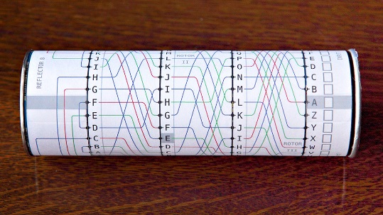
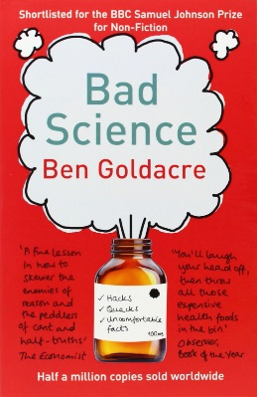
- Make enigma machines out of the tubes
- Text each other coded messages whilst sunbathing (in the rain)
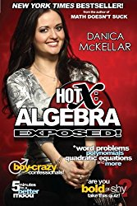
Answer: Because the author Lewis Carroll (aka Rev Charles Dodgson) invented the Carroll diagram

