Interpreting graphs

1. This graph shows the cost of hiring a carpet cleaner for up to ten days:
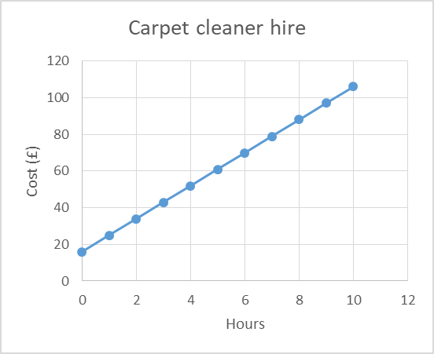

The company asks you to pay a fixed cost, no matter how long you hire a cleaner for. How much is it?

How much does it cost to hire for 7 hours?

The company changes it’s pricing policy to £12 per hour with no fixed charge. Plot this new pricing scheme. Describe how it compares with the original pricing system

2. This graph shows the cost of hiring a bicycle from two different companies. You can hire for up to twelve days.

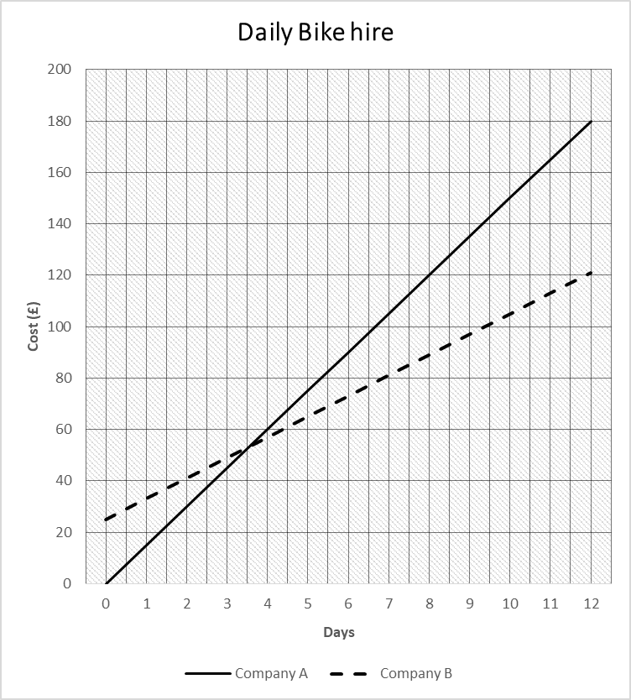

Which company charges a fixed charge? Estimate how much it is.

Estimate how much it costs to hire a bike for 2 days from each company.

Estimate how much it costs to hire a bike for 10 days from each company.

