Iphone X mini investigation

New mobile phones are very expensive, especially the latest models.

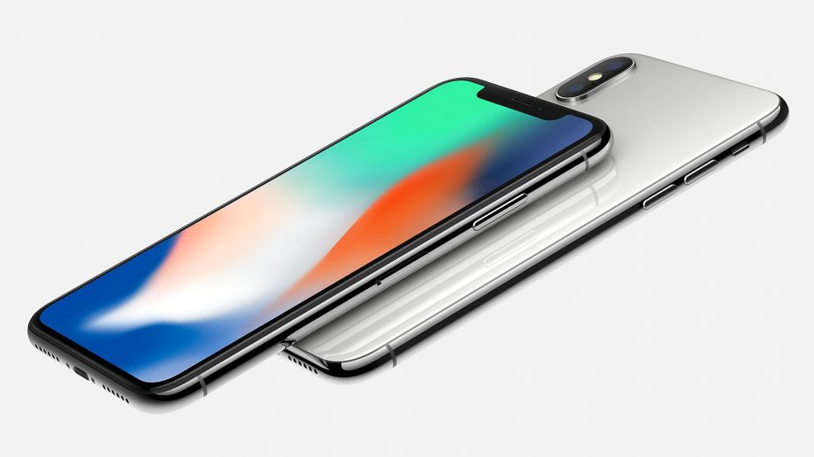

Doing your research can save you a lot of money.

What information can you find out about this comparison graph for three iphone X contracts?

What does the value at 0 months mean?

What happens when the lines cross?

Why might you want to choose a more expensive option?

Summary Data

Months | Oxygen | Vodatel | Vidaphone
0 | 30 | 300 | 99
1 | 107 | 356 | 173
2 | 184 | 412 | 247
3 | 261 | 468 | 321
4 | 338 | 524 | 395
5 | 415 | 580 | 469
6 | 492 | 636 | 543
7 | 569 | 692 | 617
8 | 646 | 748 | 691
9 | 723 | 804 | 765
10 | 800 | 860 | 839
11 | 877 | 916 | 913
12 | 954 | 972 | 987
13 | 1031 | 1028 | 1061
14 | 1108 | 1084 | 1135
15 | 1185 | 1140 | 1209
16 | 1262 | 1196 | 1283
17 | 1339 | 1252 | 1357
18 | 1416 | 1308 | 1431
19 | 1493 | 1364 | 1505
20 | 1570 | 1420 | 1579
21 | 1647 | 1476 | 1653
22 | 1724 | 1532 | 1727
23 | 1801 | 1588 | 1801
24 | 1878 | 1644 | 1875

Additional information cards
Vodatel
£300 upfront

£56 per month

24 month contract
Vidaphone
£99 upfront

£74 per month

2 year contract
Oxygen
£30 upfront

£77 per month

2 year contract

Which contract is the best value?

